**IFT 266 Introduction to Network Information Communication Technology (ICT)   
  
Lab 29**

**DHCPv6 Wired & Wireless Configuration**

Co-authored by Jorge Charles Loseth

**After you complete each step, put a ‘√’ or ‘x’ in the completed box**

**Or**

**Insert a screenshot where required.**

**Objective:** This lab will show you the steps to connect both wired and wireless devices successfully. Please put an **‘X’** in the corresponding boxes once you have completed each step.

1. Set up the following topology in Packet Tracer.

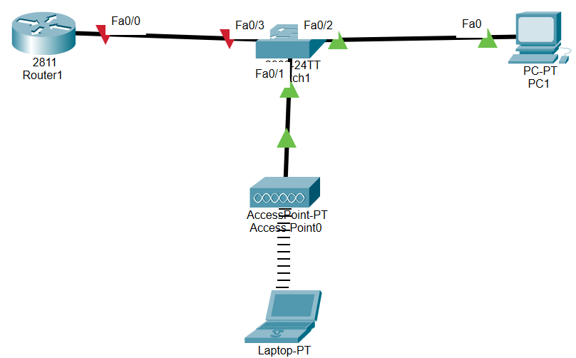



1. We will now configure the router for the following:

* Enable unicast routing
* Create a DHCP pool so that we may attain addresses for both the PC and laptop (we need to set up a pool, a prefix, server, and domain name)
* Set up a prefix for the LOCAL pool we just created
* Change the interface for the router so we can activate it

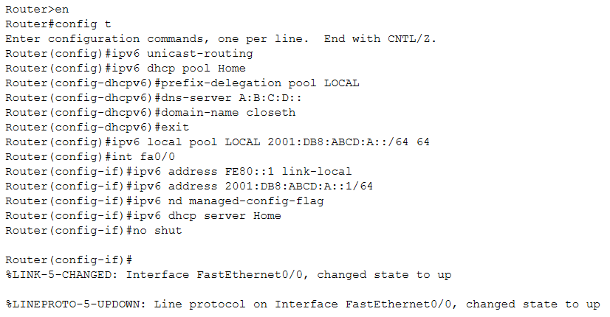

1. If you have completed all the steps correctly you should be able to go into the ‘IP Configuration’ tab under the ‘Desktop’ of the PC, go to the IPv6 area, and click ‘DHCP’. The PC should now be configured for IPv6.

**TIP**

You’re your current version of packet tracer may not have the DHCP configure option on the PCs.   
Download Packet Tracer Version 6.1.1 from below this lab and it will be there on the PCs.



1. Repeat the same IPv6 configuration for the laptop as you did for the PC in step 3.



1. Now that you have successfully received addresses for the PC and the laptop you should be able to ping each of them from the other’s device.   
     
   Attach a screenshot of your successful ping below.